First Lines Form
Name Text

TPRC (Think, Predict, Read, Connect) Form
Name Text/Topic
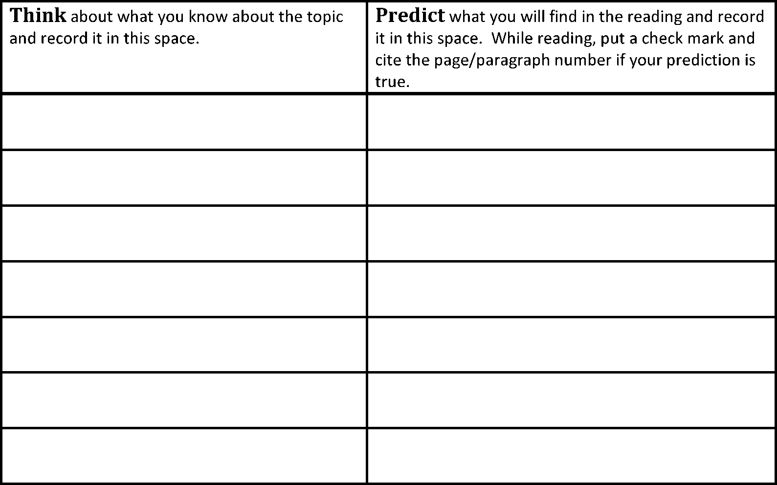

Read Connect what you knew about the topic, your predictions, and what you learned in this space.

Dump and Clump Form
Name Text/Topic

Dumpster

Clumpster

Frayer Model Form

d/ r o
W
pt
ce n
o

Examples
Definitions
C
Name Text/Topic

Non-Examples
Characteristics

PAVE (Predict, Associate, Verify, Evaluate) Form
Name Text/Topic
Copy the context sentence.

Write the target word.

Predict the word’s meaning.

Write one good sentence using the word’s predicted meaning.

Use the dictionary to verify the word’s meaning.

Write another good sentence using the word’s verified definition.

Draw a picture to associate with the word’s meaning.

Predict-O-Gram (Literary) Form
Characters
Action
Setting
Vocabulary
Name Text/Topic
Conflict/Problem
Resolution
Oddballs

Predict-O-Gram (Informational) Form
_______________
_____________________
____________________
Vocabulary
Name Text/Topic
_____________________
____________________
_______________

Vocabulary Knowledge Rating Scale Form
Name Text/Topic
1 = I don’t know the word.
2 = I have seen or heard the word. 3 = I think I know the word.
4 = I know and can use the word.
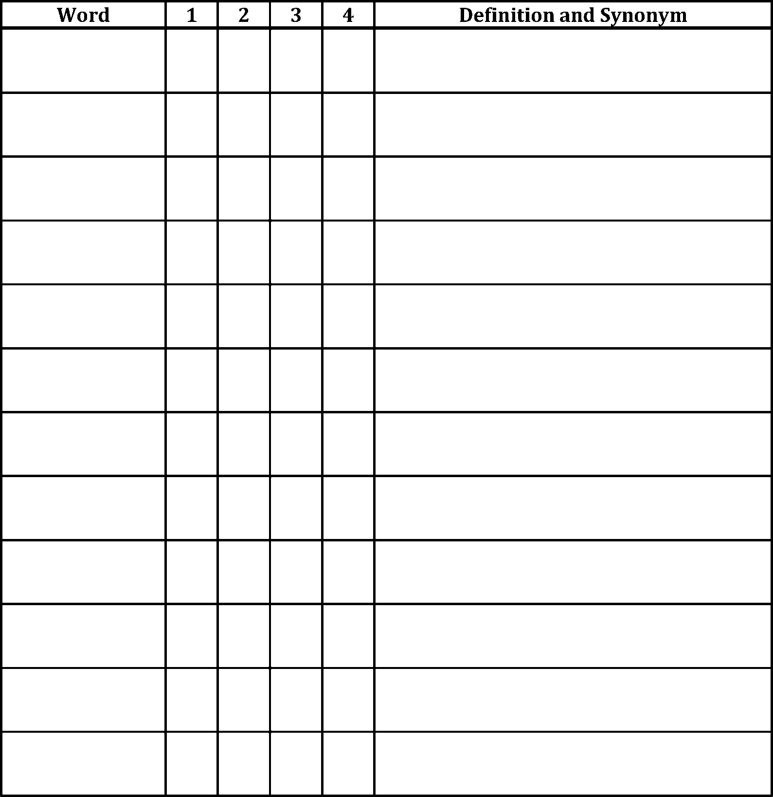

Vocabulary Self-Collection Strategy Form
Name Text/Topic

Word Expert Card Form
Name Text/Topic

It Says, I Say, and So Form
It Says: Direct quote (cite text evidence)
I Say: What does that mean? (interpretation)
And So: Put it together to answer the question (Inference)
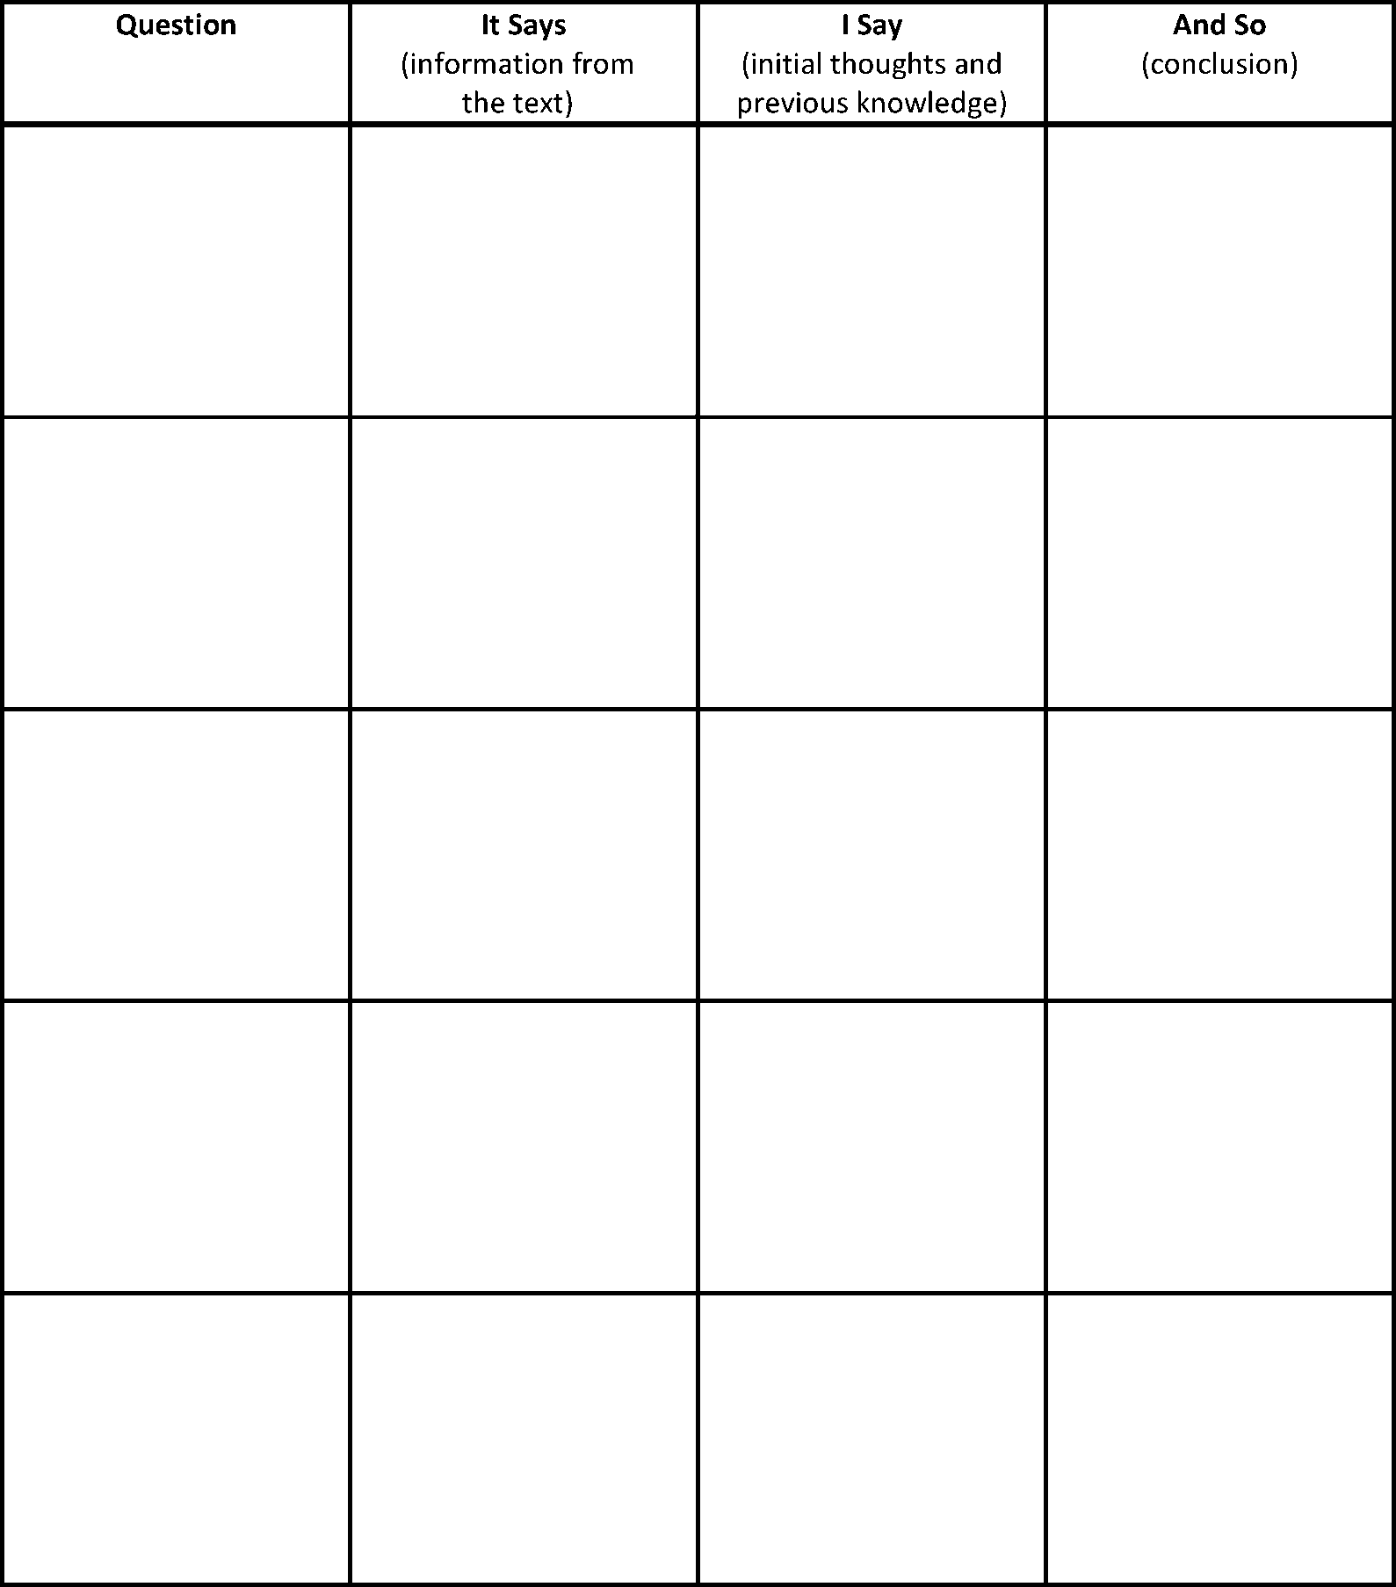

Eyewitness Testimony Form
Name Text

The FRAME Form
Name Topic/Text
Focus on the topic Reveal the main ideas. Analyze the details.
Make a “so what” statement.
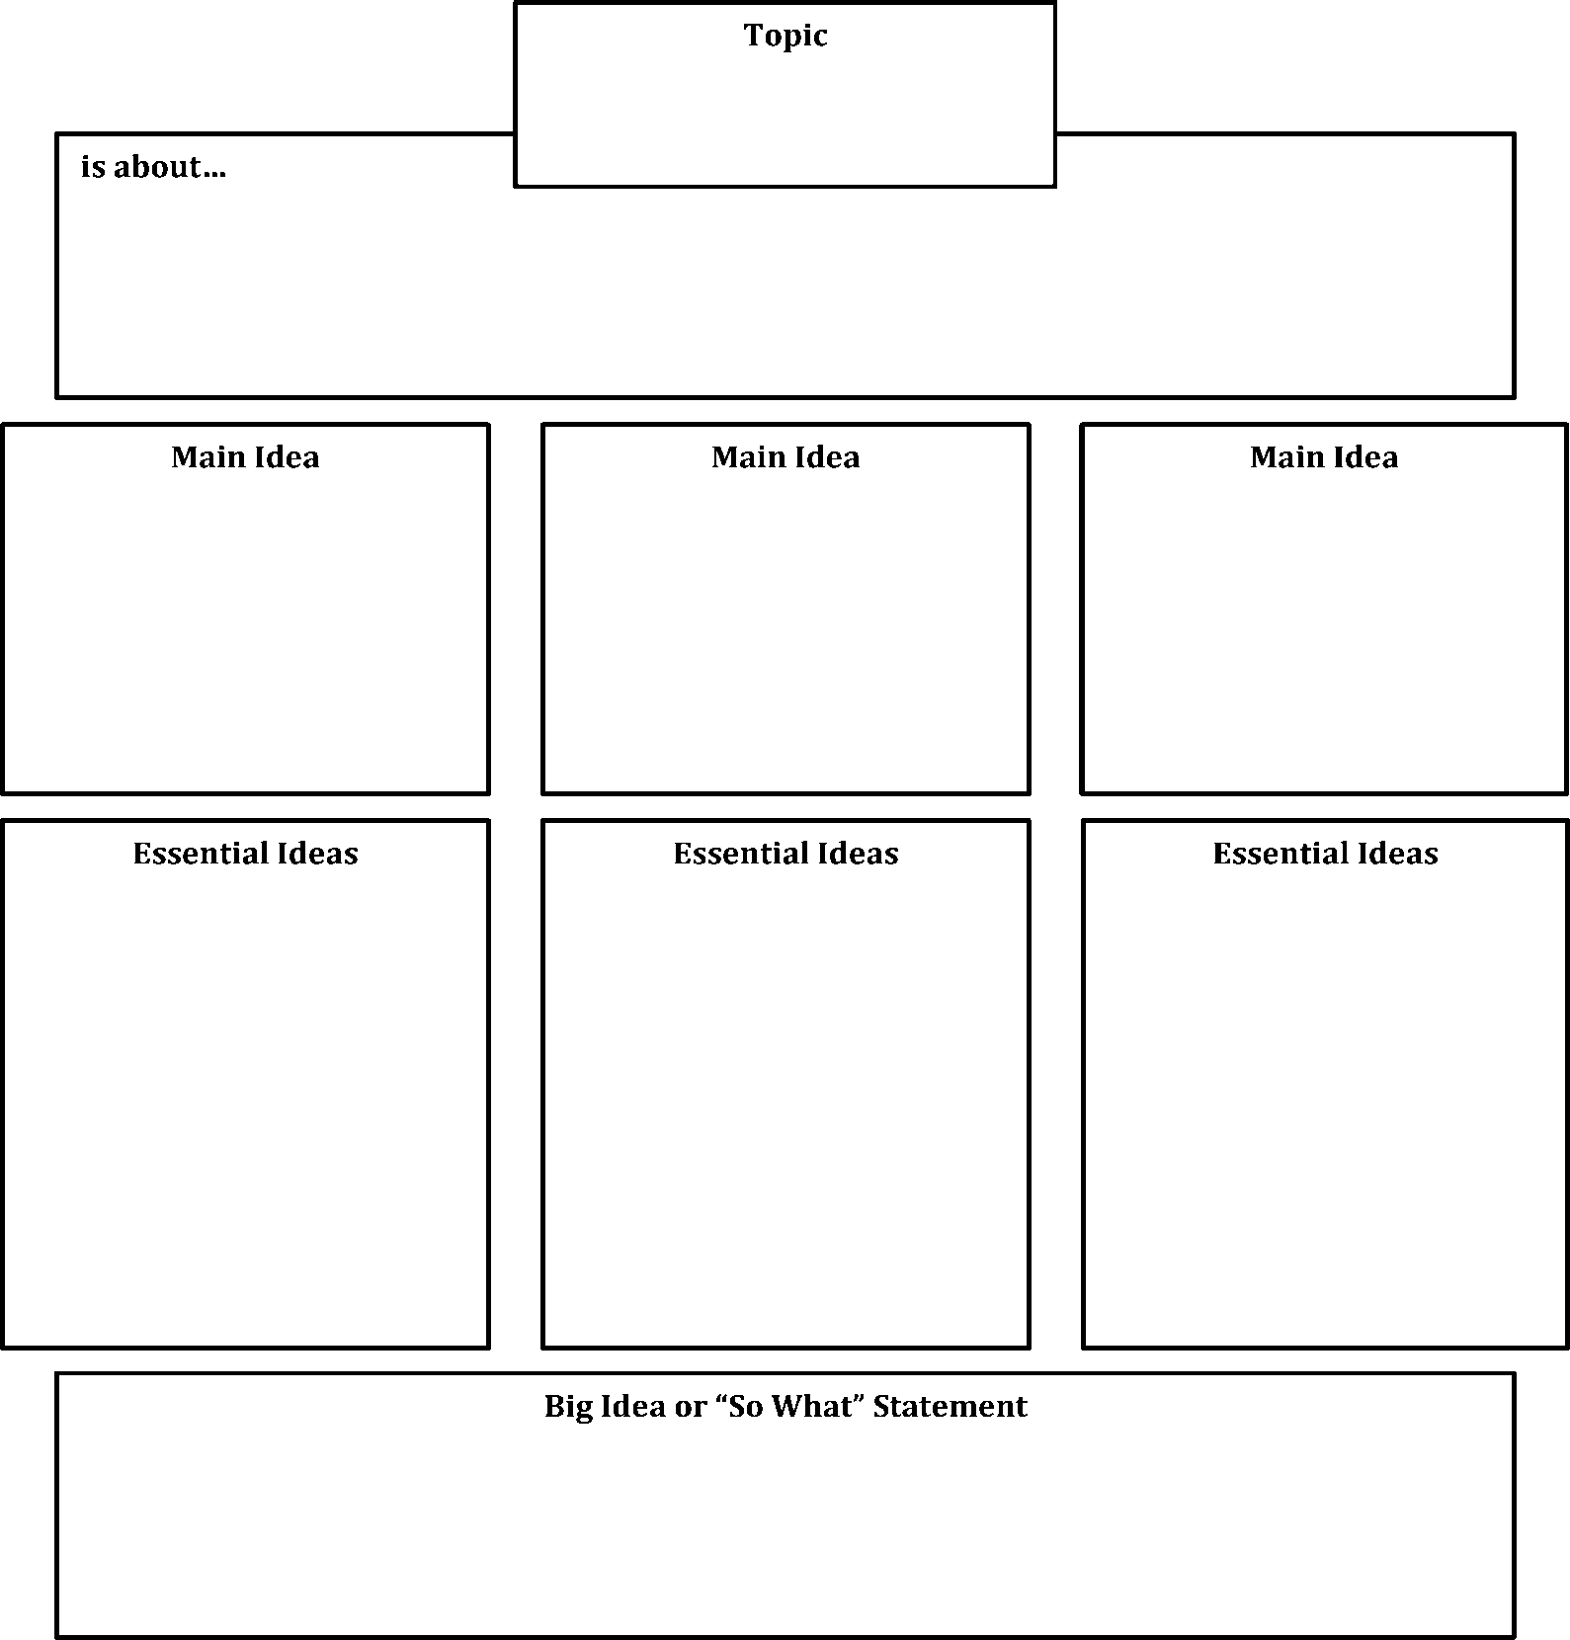
Extend your understanding.

GIST Summary Writing Form
Name Topic/Text
- Read the sections and write a one-sentence summary. It may be helpful to answer 5 Ws and H questions (Who, What, Where, When, and How).

Section 1:

Section 2:

Section 3:

Section 4:

Section 5:

- Highlight or underline key words from each section. Use those words to write a 20-word GIST.

